The data has been collected from the year 1966 to 2012 for the yield obtained for three different crops paddy,maize and cereals in arjunanadi . Along with this the values of hydrological,meteorological,agricultural drought has been considered in analyzing the data.

The parameters considered are hydrological drought, agricultural drought , meteorological drought and yield to area under cultivation ratio. The ratio is considered for normalization of the data.

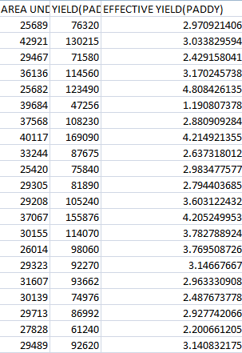

Table 1 yield to area under cultivation ratio

Recursive Feature Elimination:

In this algorithm, the given set of features are given additional priority, by an estimator. Then fewer features are selected by recursively considering smaller and smaller sets of features by training on the estimator. The least important features are removed recursively at each iteration and then the rank of the features is obtained.

Steps Involved:

* Input [X]: Meteorological, Hydrological and Agricultural drought values from the given set of data(where X is a 3-D Matrix).
* Target variable[y] is the Yield per Area i.e, ratio of yield to area under cultivation for each crop.
* Estimator used here is Linear Regression.
* In the RFE object we feed estimator and number of features to select(1 in this case).
* Now we perform recursive analysis using X and y as parameters by fitting the parameters on the estimator.
* In the end we rank the features according to its performance on the estimator.

Code:

|  |
| --- |
|  |
|  | model =LinearRegression() |
|  | rfe= RFE(model, n_features_to_select=1) |
|  | mapping = {0:'Meteorological', 1:'Hydrological',2:'Agricultural'} |
|  |  |
|  | fit =rfe.fit(X, y_paddy) |
|  | Paddy=pd.DataFrame(fit.ranking_) |
|  | Paddy.columns= ['Rank'] |
|  | Paddy=Paddy.rename(mapping) |
|  | Paddy.plot.bar(title='Paddy' ,rot=0) |

RESULT:-

Note:-

For all the respective graph lower the rank , higher it affects the yield of the respective crop.

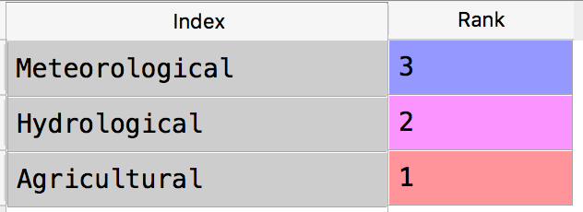



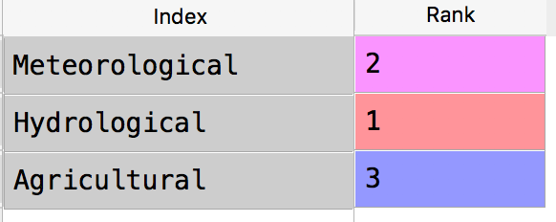



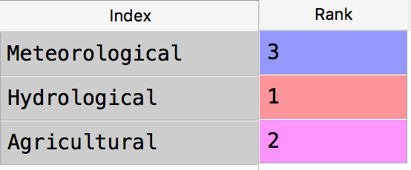



In paddy, Agricultural drought affects the yield the most.

In Maize, Hydrological Drought affects the yield the most.

In Cereals, Hydrological Drought affects the yield the most.

To reconfirm the results further, we use five more algorithms to find the coefficients of input data and rank the features according to mean obtained from them. These algorithms are:

1. Randomized Lasso:

Randomized Lasso is used to find the stability of features. We repeatedly apply Lasso algorithm on different subsets of the given data and summarize the results based on importance of the features. Lasso performs feature selection and regularization to obtain the important set of features.

Steps Involved:

* Input [X]: Meteorological, Hydrological and Agricultural drought values from the given set of data(where X is a 3-D Matrix).
* Target variable[y] is the Yield per Area i.e, ratio of yield to area under cultivation for each crop.
* In randomized Lasso object we feed the values of X and y.
* The features are ranked according to the coefficients returned after completing the calculations.

Code:-

|  |  |  |  |  |  |  |  |  |  |  |  |  |
| --- | --- | --- | --- | --- | --- | --- | --- | --- | --- | --- | --- | --- |
| rlasso=RandomizedLasso(alpha=0.04)   |  |  | | --- | --- | |  | mapping = {0:'Meteorological', 1:'Hydrological',2:'Agricultural '} | |  | fit=rlasso.fit(X,y_paddy) | |  | Paddy=pd.DataFrame(fit.scores_) | |  | Paddy.columns= ['Scores'] | |  | Paddy=Paddy.rename(mapping) | |  | Paddy.plot.bar(title='Paddy',color='g',rot=0) | |

RESULT:

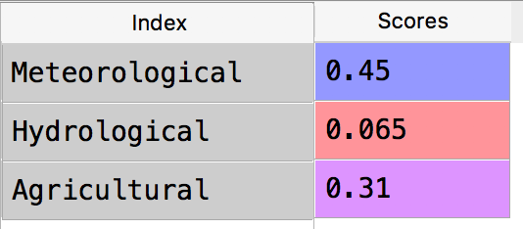



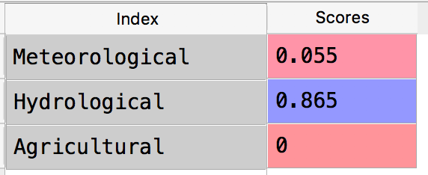



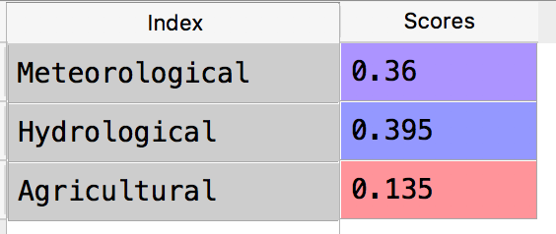



In paddy, Meteorological drought affects the yield the most.

In Maize, Hydrological Drought affects the yield the most.

In Cereals, Hydrological Drought affects the yield the most.

2. Linear Regression:

Linear regression establishes a relationship between dependent variable(y) and one or more independent variables(X) using a best fit straight line.

Steps Involved:

* Input [X]: Meteorological, Hydrological and Agricultural drought values from the given set of data(where X is a 3-D Matrix).
* Target variable[y] is the Yield per Area i.e, ratio of yield to area under cultivation for each crop.
* In Linear Regression object we feed the values of X and y.
* The features are ranked according to the coefficients returned after completing the calculations.

Code:-

lr==LinearRegression()

mapping={0:'Meteorological',1:'Hydrological',2:'Agricultura'}

lr.fit(X,y_paddy)

Paddy=pd.DataFrame(np.abs(lr.coef_))

Paddy.columns= ['Coefficients']

Paddy=Paddy.rename(mapping)

Paddy.plot.bar(title='Paddy',color='g',rot=0)

|  |
| --- |
|  |

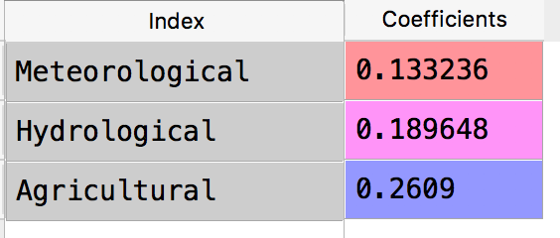RESULT:-

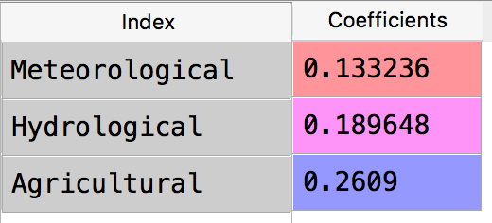



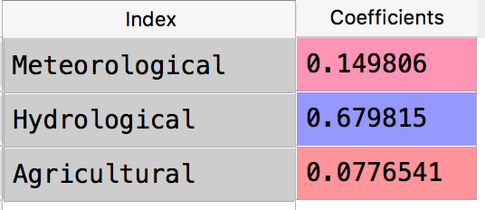







In paddy, Agricultural drought affects the yield the most.

In Maize, Hydrological Drought affects the yield the most.

In Cereals, Hydrological Drought affects the yield the most.

3. Ridge Regression

We use Ridge regression when the input values are highly correlated i.e, when the input values are dependent on each other. It performs regularization by adding penalty equivalent to the square of the magnitude of coefficients.

Steps Involved:

* Input [X]: Meteorological, Hydrological and Agricultural drought values from the given set of data(where X is a 3-D Matrix).
* Target variable[y] is the Yield per Area i.e, ratio of yield to area under cultivation for each crop.
* In Ridge regression object we feed the values of X and y.
* The features are ranked according to the coefficients returned after the calculations.

Code:-

|  |
| --- |
|  |
|  | ridge = Ridge()  mapping = {0:'Meteorological', 1:'Hydrological',2:'Agricultural'} |
|  | ridge.fit(X,y_paddy) |
|  | Paddy=pd.DataFrame(np.abs(ridge.coef_)) |
|  | Paddy.columns= ['Coefficients'] |
|  | Paddy=Paddy.rename(mapping) |
|  | Paddy.plot.bar(title='Paddy',color='g',rot=0) |

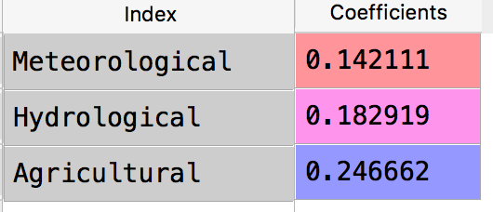

RESULT:-

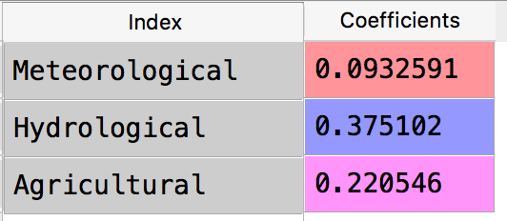



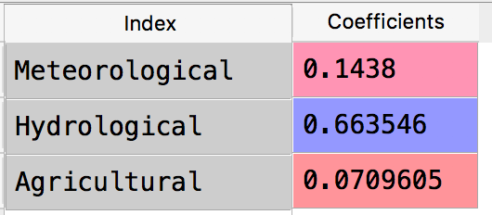







In paddy, Agricultural drought affects the yield the most.

In Maize, Hydrological Drought affects the yield the most.

In Cereals, Hydrological Drought affects the yield the most.

4. Lasso Regression:

Lasso is Least Absolute Shrinkage and Selection operator. It performs variable selection and shrinkage to improve the accuracy of predictions. It performs regularization by adding penalty equivalent to the absolute value of the magnitude of coefficients.

Steps Involved:

* Input [X]: Meteorological, Hydrological and Agricultural drought values from the given set of data(where X is a 3-D Matrix).
* Target variable[y] is the Yield per Area i.e, ratio of yield to area under cultivation for each crop.
* In Lasso Regression object we feed the values of X and y.
* The features are ranked according to the coefficients returned after the calculations.

Code:-

|  |
| --- |
|  |
|  | ridge = Ridge()  mapping = {0:'Meteorological', 1:'Hydrological',2:'Agricultural'} |
|  | ridge.fit(X,y_paddy) |
|  | Paddy=pd.DataFrame(np.abs(ridge.coef_)) |
|  | Paddy.columns= ['Coefficients'] |
|  | Paddy=Paddy.rename(mapping) |
|  | Paddy.plot.bar(title='Paddy',color='g',rot=0) |

RESULT:-

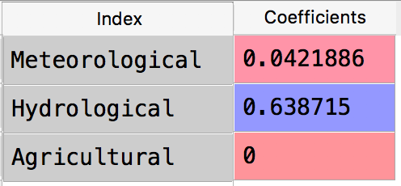

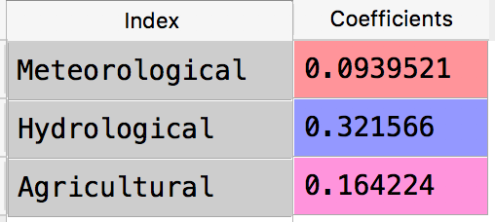



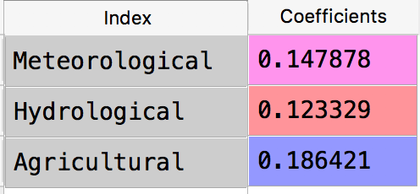



In paddy, Agricultural drought affects the yield the most.

In Maize, Hydrological Drought affects the yield the most.

In Cereals, Hydrological Drought affects the yield the most.

5. Random Forest Regressor:

Random forest Regressor makes use of sub-sampling techniques to classify the decision trees to improve the accuracy of the output obtained. We fit a regression model to the target variable using each independent variable.

Steps Involved:

* Input [X]: Meteorological, Hydrological and Agricultural drought values from the given set of data(where X is a 3-D Matrix).
* Target variable[y] is the Yield per Area i.e, ratio of yield to area under cultivation for each crop.
* In Random Forest Regressor object we feed the values of X and y.
* The features are ranked according to the coefficients returned after the calculations.

Code:-

|  |
| --- |
|  |
|  |
|  | rf=RandomForestRegressor()  mapping = {0:'Meteorological', 1:'Hydrological',2:'Agricultural'} |
|  |  |
|  | rf.fit(X,y_paddy) |
|  | Paddy=pd.DataFrame(np.abs(rf.feature_importances_)) |
|  | Paddy.columns= ['Importances'] |
|  | Paddy=Paddy.rename(mapping) |
|  | Paddy.plot.bar(title='Paddy',color='g',rot=0) |
|  |  |

RESULT:-

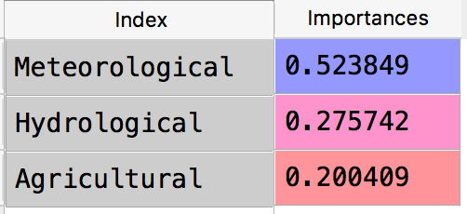

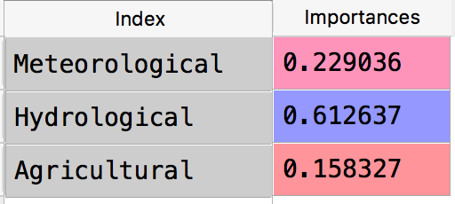

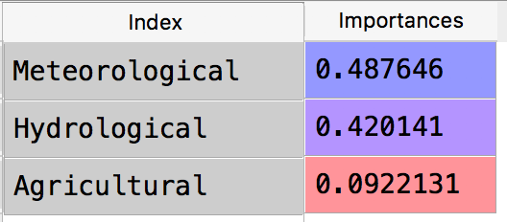



In paddy, Meteorological drought affects the yield the most.

In Maize, Hydrological Drought affects the yield the most.

In Cereals, Meteorological Drought affects the yield the most.

Conclusion:

We took the coefficient values of input X for the above five algorithms. We took the mean of the values and plotted it to confirm our initial results.

